**Observation**

Millions of hectares of lodgepole pine trees have been affected by the recent mountain pine beetle (MPB) hyperepidemic in western North America (Zhao et al, 2019). Pine forests cover a large area in the western North America and provide important ecosystem services that support societal well-being at local, regional and global levels.

In 1885 Banff became the first national park in Canada, and since then four more parks have been added in Alberta alone (*figure 1*). Today, Banff, Jasper, Waterton Lakes and Wood Buffalo national Parks are part of a UNESCO World Heritage Site (Muldoon et al, ch.11, 2015). The invasion of MPB in the Alberta’s forests has the potential to impact visual quality and safety of visitors, ecosystem services and function (Folke et al., 2002; MacFarlane et al., 2006).

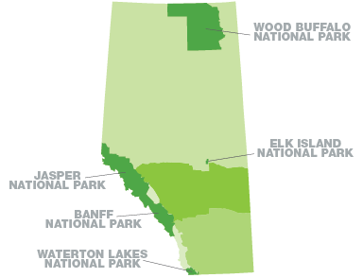

*Fig 1* – Alberta’s National Parks (source [Travel Alberta](https://www.travelalberta.com/ca/places-to-go/national-parks/))

The mountain pine beetle (MBP) (*Dentroctonus ponderosae* Hopkins) is a native invasive pest of North America which has expanded its range north in latitude and up in elevation into novel habitats in the within genus *Pinus* (*Pinus contorta*) (Burke & Carroll, 2016; Sambaraju et al, 2019). A “before and after” picture (*photo 1*) illustrates the two years difference, between 2015 and 2017 of MBP attack, by Patricia Lake in Jasper National Park, Alberta, Canada. *Figure 2* illustrates the distribution of the lodgepole pine in North America.

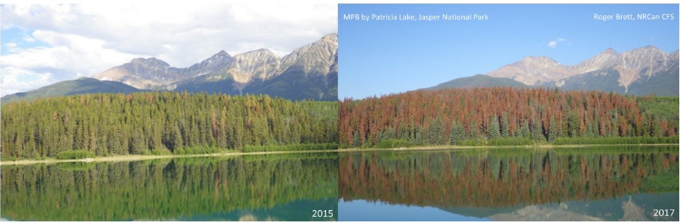

*Photo 1* - Patricia Lake, Jasper National Park (source: twitter [Tzeporah Berman](https://twitter.com/Tzeporah/status/1085750305562648576))

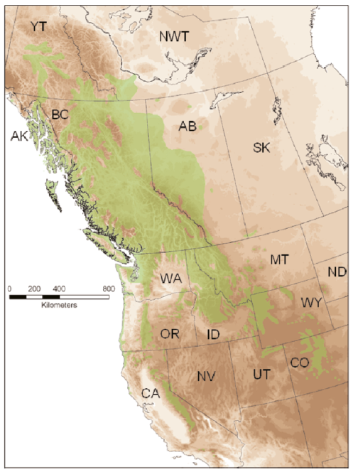

*Fig.2 -* Distribution of lodgepole pine in North America (source Carroll, A. L., 2007)

**Interpretation:**

In the case of MBP changed disturbance regimes could drive biome-level shifts in vegetation structure with cascading socio-economic consequences. In the context of a continuous lengthening of the growing seasons, longer periods of drought, correlated with the direct effects of a warming climate, the expansion and the intensity of bark beetle outbreaks pose a risk of major changes to large areas of forests in North America (Campbell et al, 2019). The “ecological memory” is lost after chronic invasions, as an ecosystem does not have the capacity to return to initial state, creating new ecosystem. Webster et al. (2018) defines “ecological memory as the information and material legacy that guide ecosystem reorganization after disturbances and shape response to future disturbances”. In the lodgepole pine dominated forests of Alberta, monoculture, climate change, fire suppression over-management changed the external variability experienced by forests ecosystem becoming less resilient (Holling, 1986). Successive disturbances erode the forest’s resilience and thus the incapacity to regenerate to its original (Filotas et al, 2014).

**Expert Consult:**

My chosen expert consult is Allan L. Carroll, Professor and Director for Forest Sciences at University of British Columbia, Canada. His expertise covers research areas that refer to role of climate change in the population dynamics and impacts of eruptive forest insects, co-evolution of insect-plant interactions, integrated pest management of insect populations. Although, I was not able to reach him and to get his feedback regarding my observations, Carroll confirms that the recent MPB “hyperepidemic” in western Canada “occurred as ameliorating temperature conditions, presumably due to climate change, coincided with landscape of susceptible host trees brought about by altered disturbance regime such as aggressive fire suppression”(Carroll et al, 2004).

In the last century, epidemics of the MPB have occurred four times within the pine forests in western North America, but collapsed as consequence of localized depletion of suitable host trees combined with adverse effects of climate (Carroll, 2007).

**Conclusion**

Anthropogenic drivers, such as climate change expansion and forest management activities are affecting the distributions and abundance of susceptible infected trees. Sambaraju et al. (2019) identified that under the influence of multiyear drought conditions and temperature increases, the MPB population could migrate to higher elevations and northern latitudes (e.g. boreal forests), with greater future epidemics in North America. In the case of MPB outbreak new platforms for adaptive management and resilience-building will help to generate diversity and multi-level governance capable to respond to transformations, uncertainties and surprises (Folke et al, 2002).

To minimize the risk of MPB outbreaks and expansion, short-term and long-term strategies are recommended, such as pest control, aggressive monitoring (very effective in Alberta) to detect incipient MBP infestations by “removing and destroying infested trees at a rate and magnitude dictated by the size and rate of increase of the beetle population”, projections of extreme weather conditions (i.e. long periods of drought), but also reforestation with species that are stress-tolerant (Sambaraju et al, 2019). Regarding the interaction between the lodgepole pine and the MPB, Safranyik suggests that long term management should be focused on the trees rather than the beetle: the main causes of outbreaks are the existence of “large areas of susceptible host, such as mature lodgepole pine, combined with continued, favourable weather conditions for beetle establishment, development and survival” (Safranyik, 2006).

These strategies combined with a “deeper understanding of climatic influences on insect-host tree interactions…..will lessen the economic and ecological impacts of the MBP” (Sambaraju et al, 2019).

References

Burke, J. L., Carroll, A. L.(2016). The influence of variation in host tree monoterpene composition on secondary attraction by an invasive bark beetle: Implications for range expansion and potential host shift by the mountain pine beetle. *Forest Ecology and Management.* [doi.org/10.1016/j.foreco.2015.09.044](https://doi.org/10.1016/j.foreco.2015.09.044).

Campbell,E.M, Antos, J. A., vanAkker,L. (2019). Resilience of southern Yukon boreal forests to spruce beetle outbreaks. *Forest Ecology and Management*. doi.org/10.1016/j.foreco.2018.10.037.

Carroll, A.L., Taylor, S.W., Régnière, J., Safranyik, L. (2004). Effects of climate change on range expansion by the mountain pine beetle in British Columbia. Pages 223-232 in T.L. Shore, J.E. Brooks, and J.E. Stone, editors. Mountain Pine Beetle Symposium: Challenges and Solutions, Kelowna, British Columbia, Canada. Natural Resources Canada, Canadian Forest Service, Pacific Forestry Centre, Victoria, British Columbia.

Carroll, A. L., (2007). The Mountain Pine Beetle *Dendroctonus ponderosae* in Western North America: Potential for Area-Wide Integrated Management (pages 297-307). Area-Wide Control of Insect Pests.

Filotas, E., L. Parrott, P. J. Burton, R. L. Chazdon, K. D. Coates, L. Coll, S. Haeussler, K. Martin, S. Nocentini, K. J. Puettmann, F. E. Putz, S. W. Simard, and C. Messier. 2014. Viewing forests through the lens of complex systems science. *Ecosphere*. [doi.org/10.1890/ES13-00182.1](http://dx.doi.org/10.1890/ES13-00182.1)

Holling, C. S. (1986). The resilience of terrestrial ecosystems: local surprise and global change. In Clark, W. C. & Mann, R. E. (eds.). *Sustainable development of the biosphere.* Cambridge UK: Cambridge University Press, 292-317.

McFarlane, B. L., Craig R., Stumpf-Allen, G., Watson, D.O. (2006). Public perceptions of natural disturbance in Canada’s national parks: The case of the mountain pine beetle (*Dendroctonus ponderosae* Hopkins). Biological Conservation. doi.org/10.1016/j.biocon.2005.12.029.

Muldoon, P., Lucas, A.R., Gibson, R., Pickfield, P., & Willaims, J. (2015). Introduction to Environmental Law and Policy in Canada. 2nd ed. Toronto: Emond Press

Safranyik, L., Wilson, B. (2006). The Mountain Pine Beetle – A Synthesis of Biology, Management, and Impacts on Lodgepole Pine. Parks Canada. Retrieved from <http://cfs.nrcan.gc.ca/pubwarehouse/pdfs/26116.pdf>

Sambaraju, K. R., Carroll, A. L., Aukema, B.H. (2019). Multiyear weather anomalies associated with range shifts by the mountain pine beetle preceding large epidemics. *Forest Ecology and Management*. doi.org/10.1016/j.foreco.2019.02.011.

Travel Alberta. Retrieved from <https://www.travelalberta.com/ca/places-to-go/national-parks/>

Zhao, S., Klutsch, J.G., Cale, J. A., Erbilgin, N. (2019). Mountain pine beetle outbreak enhanced resin duct-defenses of lodgepole pine trees. *Forest Ecology and Management*. doi.org/10.1016/j.foreco.2019.03.023.

Webster, C. R., Dickinson, Y. L., Burton, J.I., Frelich, L.E., Jenkins, M. A., Kern, C. C., Raymond, P., Saunders, M.R. , Walters, M.B., Willis, J. L. (2018). Promoting and maintaining diversity in contemporary hardwood forests: Confronting contemporary drivers of change and the loss of ecological memory. *Forest Ecology and Management*. doi.org/10.1016/j.foreco.2018.01.010.